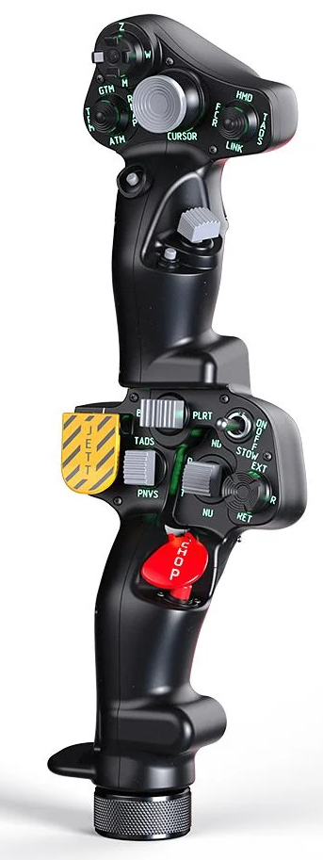  1xx - Controls | 2xx - Ground | 3xx - Flight | 4xx - A2A | 5xx - A2G | 6xx - Misc
102 - Controls - Pilot - Collective Grip Apache-64
U=Up, D=Down, F=Forward, B=Backward, L=Left, R=Right, P=Press, S-*=Shift-*, L-*=Long-*

Top Trigger
- P: --
FCR Scan Size hat (top)
- U: Flight engineer seat
- D: Cargo Hatch view??
- S-D: Cargo view??
- R: Copilot seat
- L: Pilot seat
- P: Release countermeasures
FCR Mode hat (left)
- U: --
- D: --
- L: --
- R: --
- P: Release countermeasures
Sight Select hat (right)
- U: Autopilot Roll/Pitch Channel ON
- D: Adjust Autopilot (flight engineer automatically centers autopilot trim knobs)
- L: Autopilot Heading Channel ON
- S-L: Autopilot Heading Channel OFF
- R: Autopilot Altitude Channel ON
- S-R: Autopilot Altitude Channel OFF
- P: Turn Off Autopilot
Cursor hat (Ministick)
- Axes: --
- P: --
Cursor Select button (under ministick)
- P: --
FCR Scan switch (thumb) -- Comms
- F: (SRS radio 1 PTT)
- B: (SRS radio 2 PTT)
- P: (VoiceAttack PTT)
- S-P: (VoiceAttack center mouse cursor)
Cued Search button (under thumb switch)
- P: --
Top Pinky button
- P: Wheel parking brake (toggle)
-------------------------------------------------------------------------------------------------------------------------------------
Bottom trigger
- P: Collective brake - Assign altitude lever
Boresight rocker
- L: Right Headlight Left
- P: --
- R: Right Headlight Right
Searchlight switch
- F: Left Headlight Switch ON
- B: Left Headlight Switch OFF
- B and Hold: Left Headlight Switch RETRACT
Searchlight hat
- U/D/L/R: Left Headlight Up/Down/Left/Right
- P: --
Jettison button
- P: --
- P and Hold: External stores jettison
NVS switch
- F: Right Headlight Up
- P: --
- B: Right Headlight Down
Stabilator switch
- F: Right Headlight Switch ON
- P: Right Headlight Switch RETRACT
- B: Right Headlight Switch OFF
Chop button
- P: --
- P and Hold: --
Bottom Pinky button
- P: Wheel parking brake (toggle)

